

The purpose of this lab work is to give an introduction to Packet Tracer.

Packet Tracer is a widely used tool in industry and academia for network planning and POC configurations.

You can register with the Cisco NetaCad Foundation and from here you will be able to download the tool for free.

<https://www.netacad.com/courses/packet-tracer>

Navigate to the website above

Click “introduction to packet tracer” , signup and you should have the ability to download the tool.

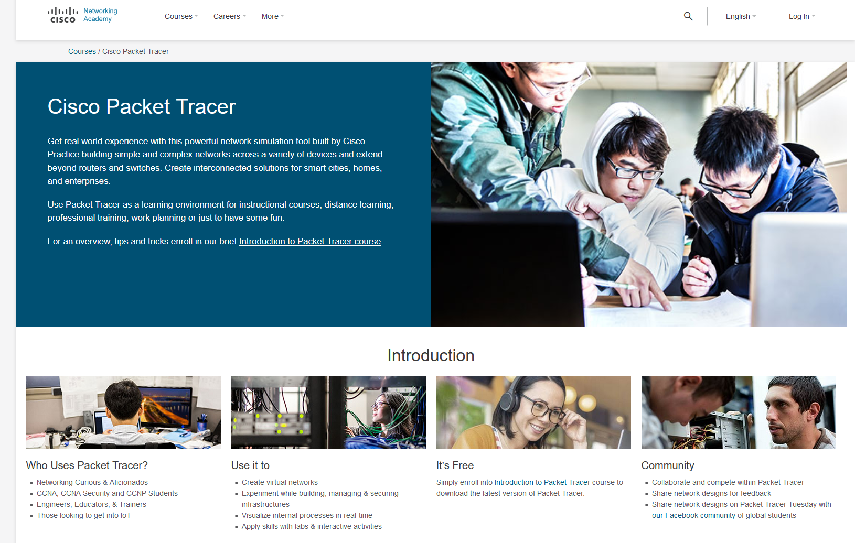



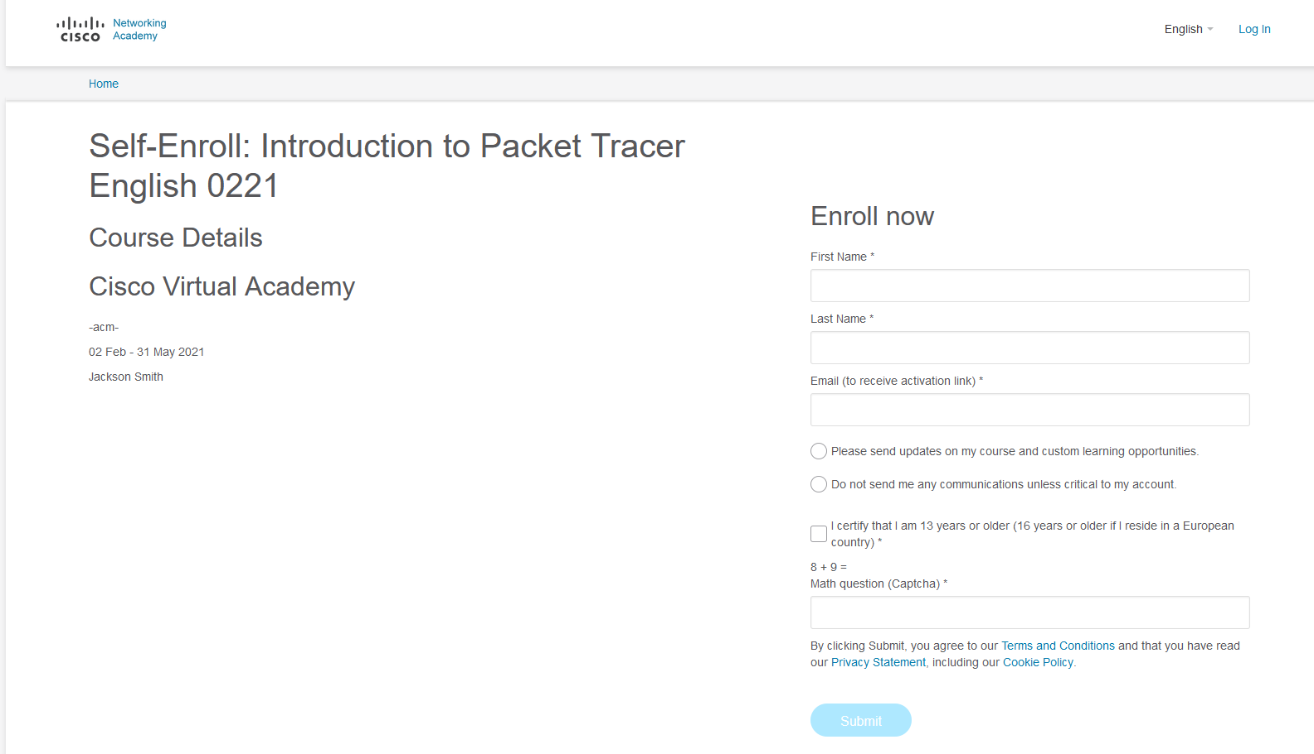

You should then receive an email confirming registration

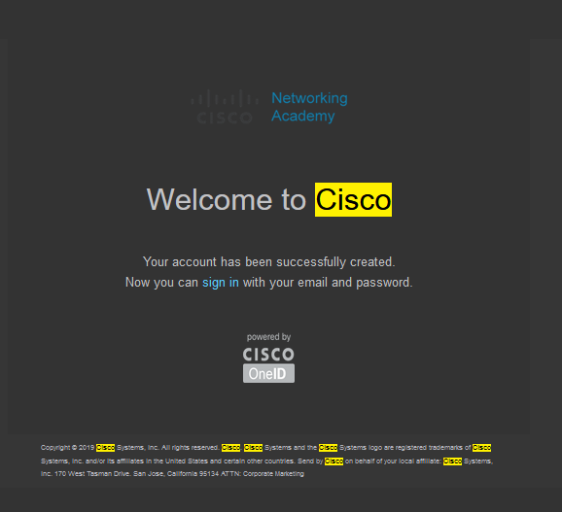

Once Packet Tracer is installed on your machine. Open the application and you will be asked to login.

You can use the same credentials used in the registration process above.

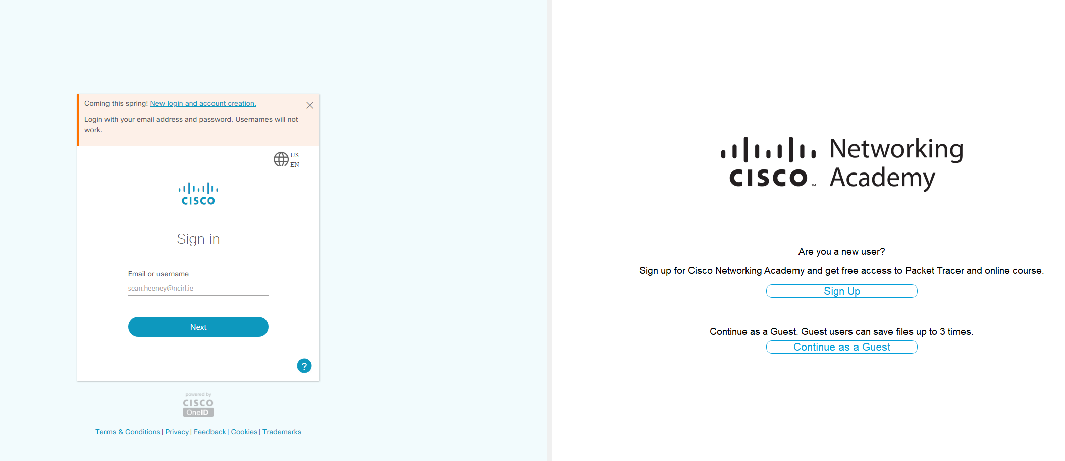

Upon completion of the above registration and installation process you should see the screen below:

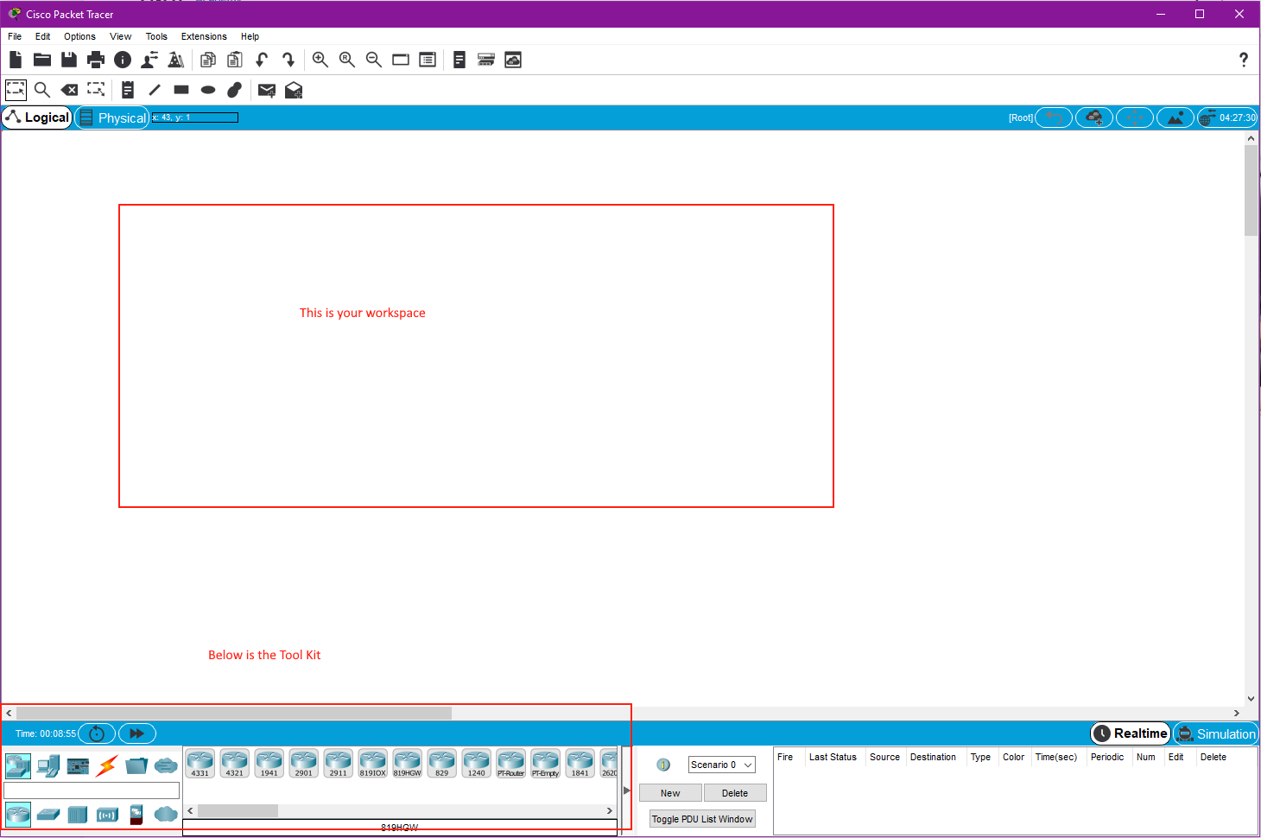

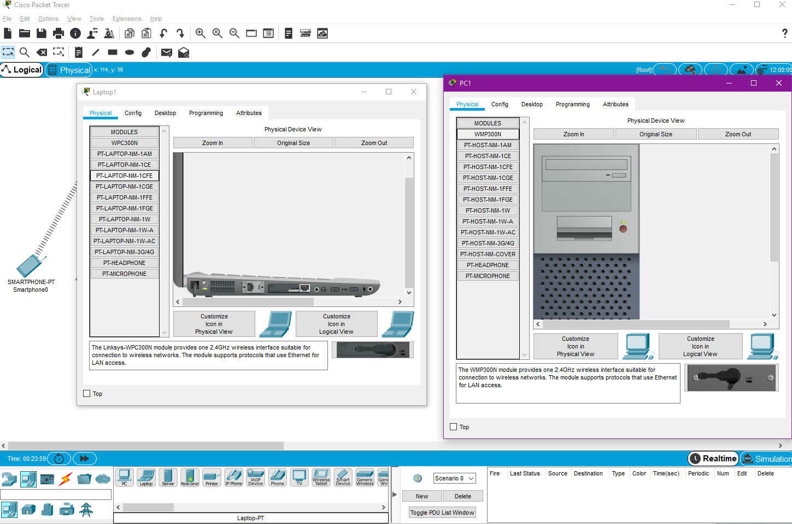

You can add an remove modules from the devices by double clicking on the device, ip configuration and access to the terminal can also be accessed through the config tab inside the device.

## Lab Task

1 Attempt to reproduce as accurately as possible your own LAN – Local Area Network

2 Attempt to resolve the configuration scenario below

You Can add a wireless router and the end devices within your own network.

I have provided an example below and potential problem to be resolved

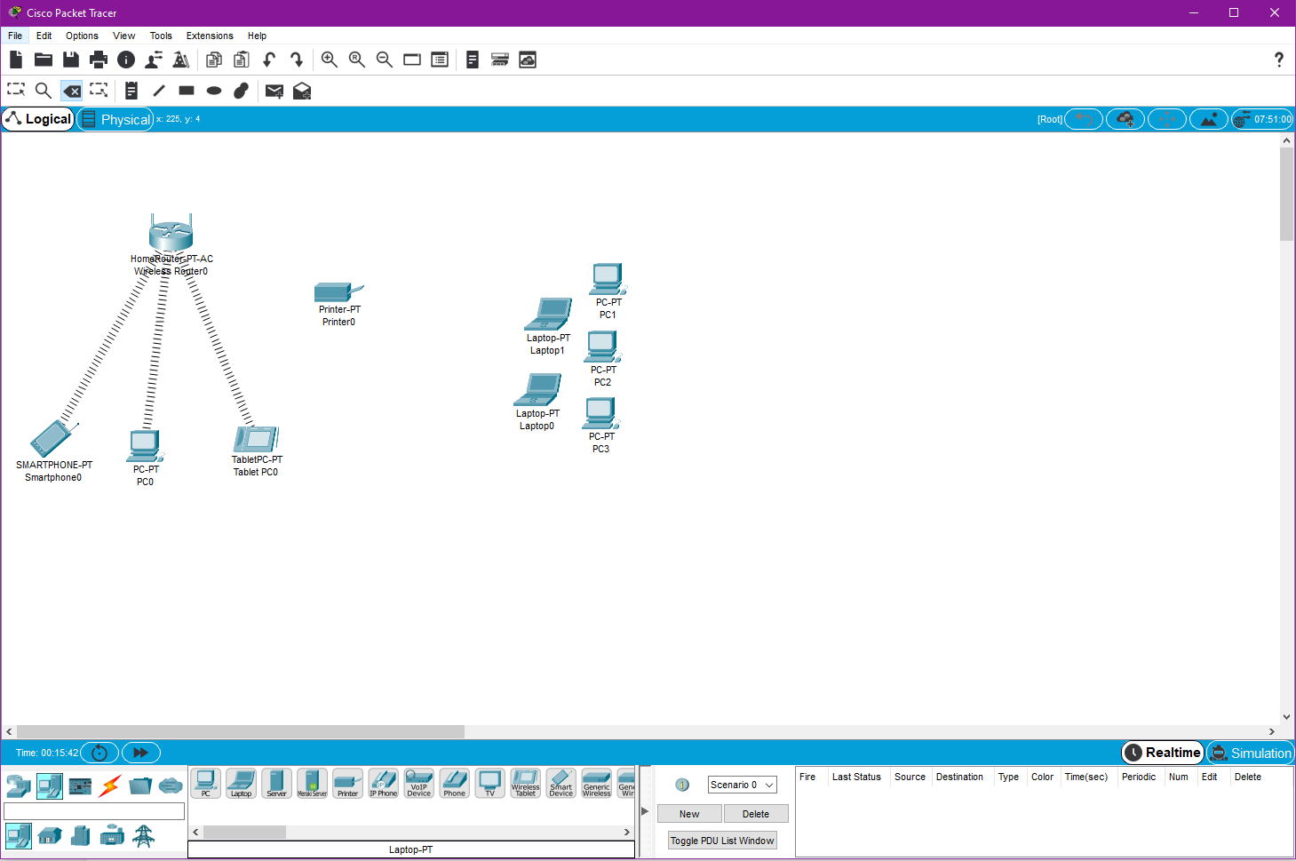

You can see from the scenario I have created above there is a typical wireless router setup which has connected to it : Tablet / Smart Phone / PC

But there is also a printer, 2 laptops and additionally 3 desktop machines.

But they are unable to connect.

Your task is to provide a means of connection for these devices to communicate to the router.

Some Clues.

DHCP is configured – Dynamic Host Control Protocol, so specific hard coding / manual config of Ips is not required.

There is currently no connection medium at use other than wireless.

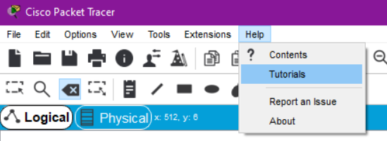Additional Resources:

<http://tutorials.ptnetacad.net/tutorials72.htm>

The above link can also be accessed here through the application